Modern Methods in Ecological Modeling, Kunming Institute of Zoology, April 2024

Exercise 1 – Occupancy modeling

Use a Eurasian lynx dataset collected in the Romanian Carpathian Mountains between December 2018 and March 2019 to run an occupancy analysis and determine:
- Naïve occupancy
- Proportion of area occupied (or overall occupancy) after accounting for imperfect detection
- The best predictor(s) for detection and occupancy
- Plot relationships between
  - detection variables and detection probability
  - occupancy variables and occupancy probability

Follow the template and workflow of the “mink frog” example; replace the detection history and detection and observation variables with the new data (see below). There is only 1 detection variable (see below), so we can skip the detection model selection step and just run several models with different combinations of variables for occupancy.

Data description:
- 64 camera trap locations in 2.7x2.7 km grid cells (this is the approximate area of a lynx core home range)
- 8 occasions (revisits) - these are 2-week or 14-day periods – columns 2-9 in the Excel file
- Detection variable: camera trap effort; some cameras did not run for the full 14 days each occasion due to battery failure, focal field obstruction by snow, etc. – columns 20-27 in the Excel file
- Occupancy variables: altitude, road density, Topographic Ruggedness Index and proportion of forest – columns 12-15 in the Excel file

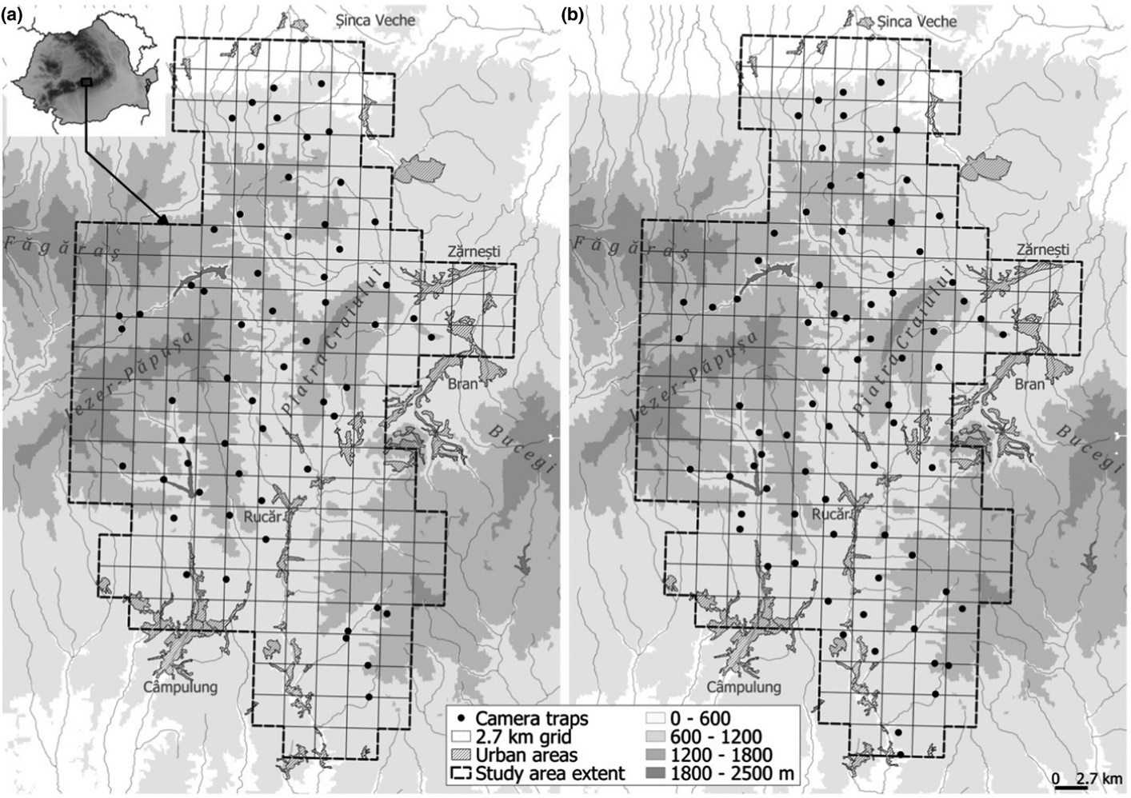
Camera trap locations for the data in exercise (panel a). Figure from:
Dyck, M. A., Iosif, R., Promberger–Fürpass, B., & Popescu, V. D. (2022). Dracula’s ménagerie: A multispecies occupancy analysis of lynx, wildcat, and wolf in the Romanian Carpathians. Ecology and Evolution, 12, e8921. https://doi.org/10.1002/ece3.8921

